
COMPANY PROFILE
Automation • Electrical • SCADA • Smart Homes • EV Charging • Remote Monitoring
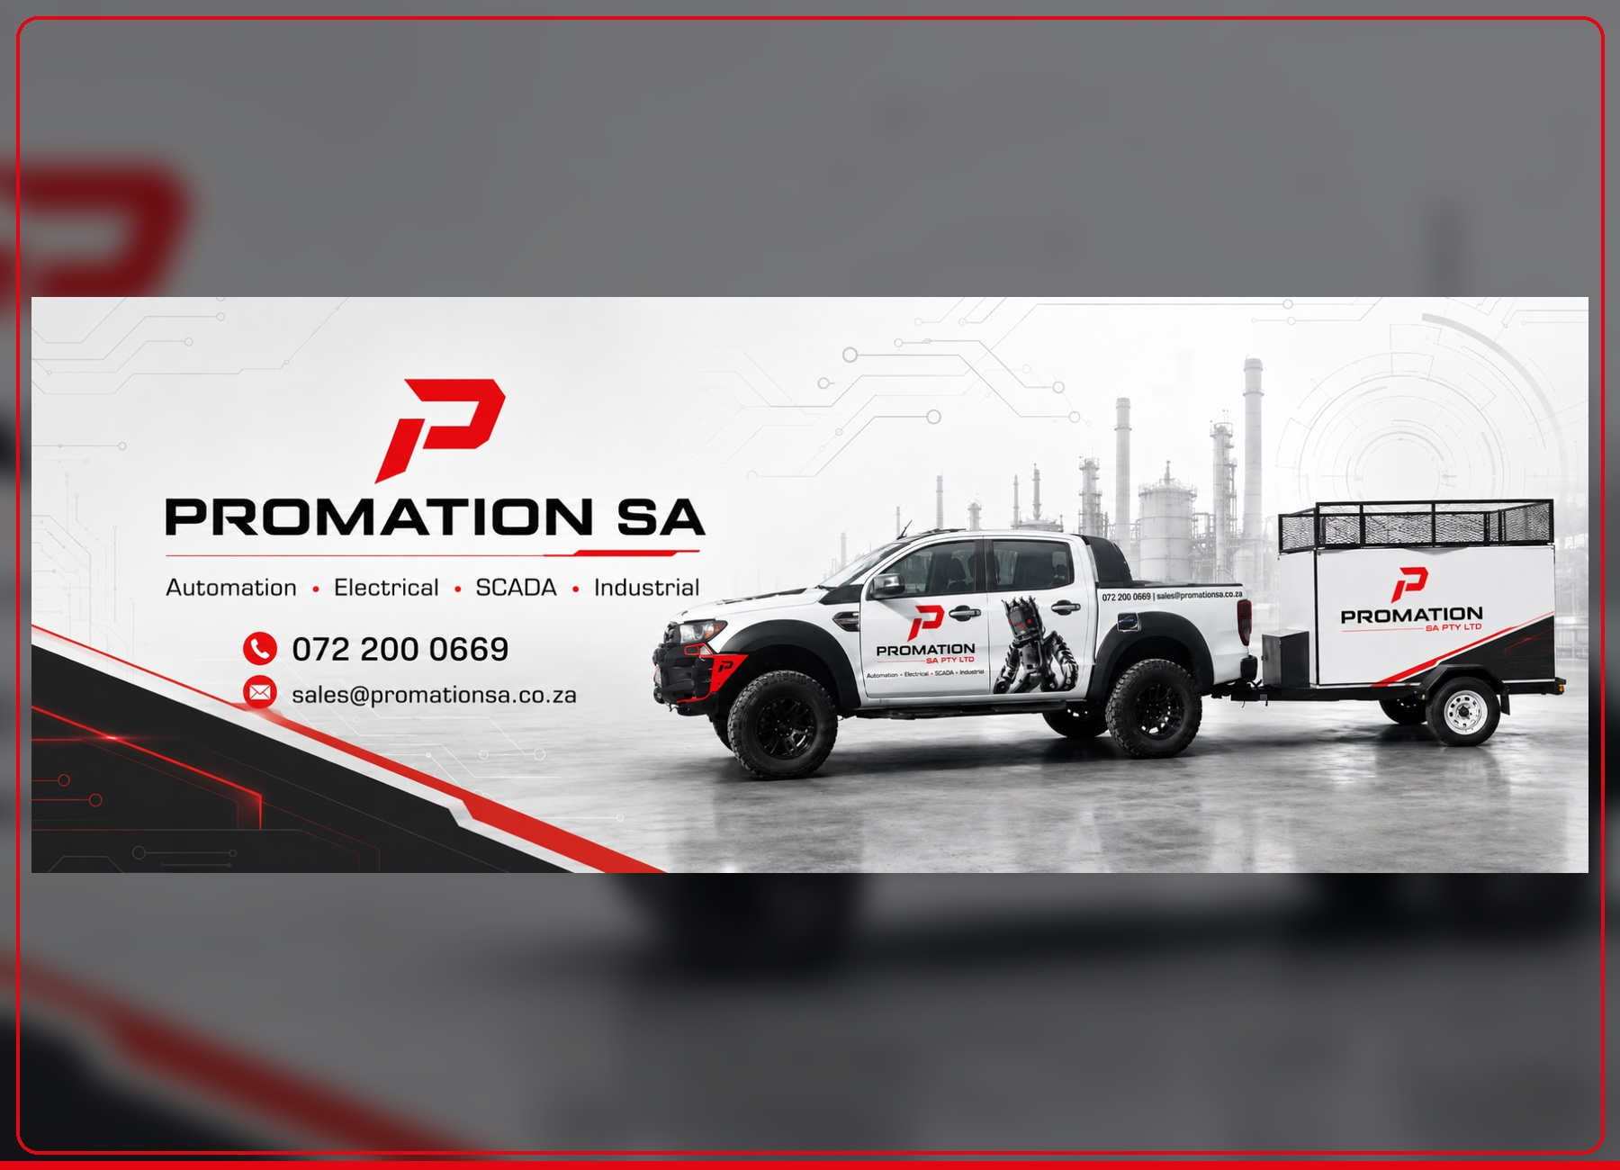
SMART SYSTEMS. RELIABLE RESULTS. PRACTICAL CONTROL FROM ANYWHERE.
STOP DOWNTIME  Find faults, alarms and equipment problems before they become expensive breakdowns. | IMPROVE CONTROL  Give owners clear dashboards, practical reporting and site visibility from anywhere. | INCREASE PERFORMANCE  Build reliable systems that reduce waste, improve reliability and support growth.

BUILT FOR OWNERS WHO WANT CONTROL | PAGE 2
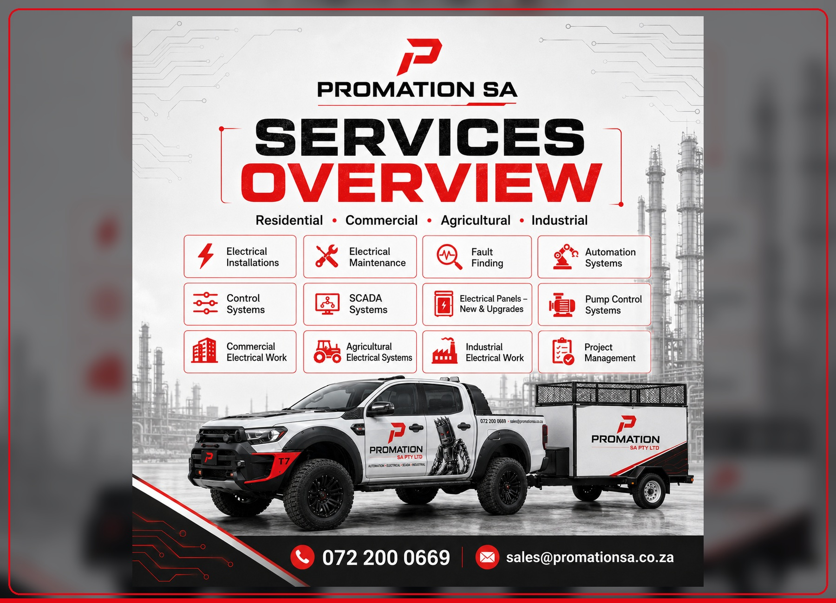
WHAT PROMATION SA DOES  ✓ Electrical installations, DB upgrades, panels and project-managed electrical work.  ✓ PLC programming, HMI screens, SCADA support and control system design.  ✓ Fault finding, maintenance, upgrades, monitoring and reporting.  ✓ Smart homes, premium accommodation, EV charging and cost-control systems. |  | WHY CLIENTS CHOOSE US  ✓ We turn technical problems into clear dashboards, alarms and practical decisions.  ✓ We design expandable systems instead of once-off fixes that limit future growth.  ✓ We focus on downtime, waste, reliability, owner visibility and long-term support.  ✓ We communicate in plain language and build around the real site conditions.
RESIDENTIAL  Smart homes, gates, access, lighting, water, solar and energy control. | COMMERCIAL  Guesthouses, lodges, carwashes, workshops, properties and retail sites. | AGRICULTURAL  Pump control, water monitoring, irrigation readiness and remote visibility. | INDUSTRIAL  Factories, plants, mines and processing facilities with PLC/HMI/SCADA needs.
THE GOAL IS SIMPLE: SAFER SYSTEMS, BETTER VISIBILITY, LESS WASTE AND STRONGER CONTROL.

INDUSTRIAL AUTOMATION, SCADA & DASHBOARDS | PAGE 3
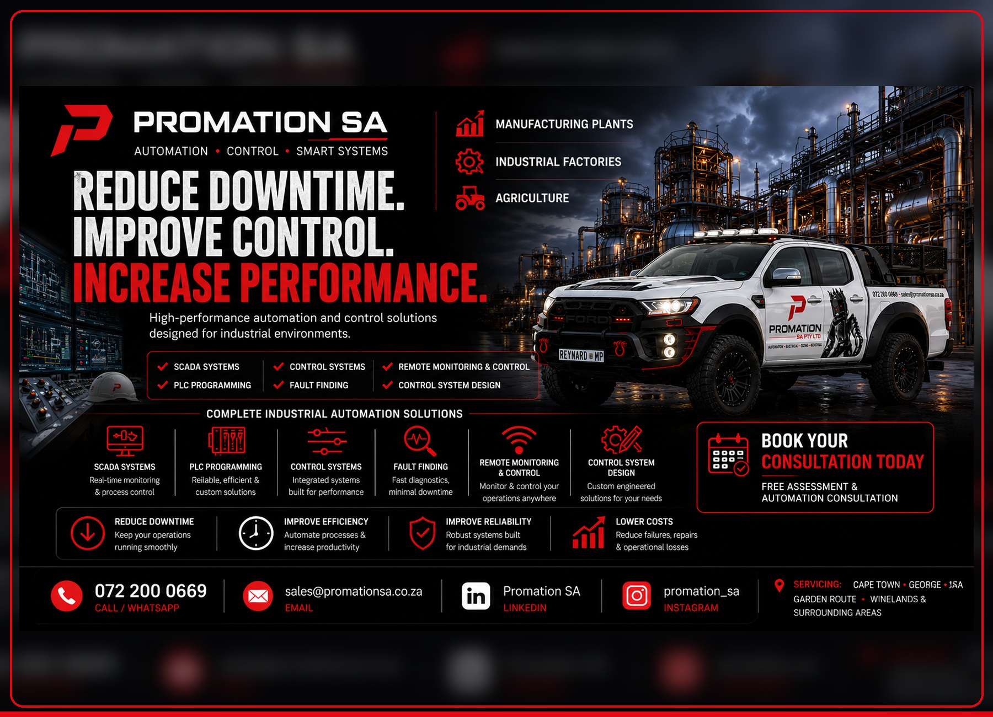 | 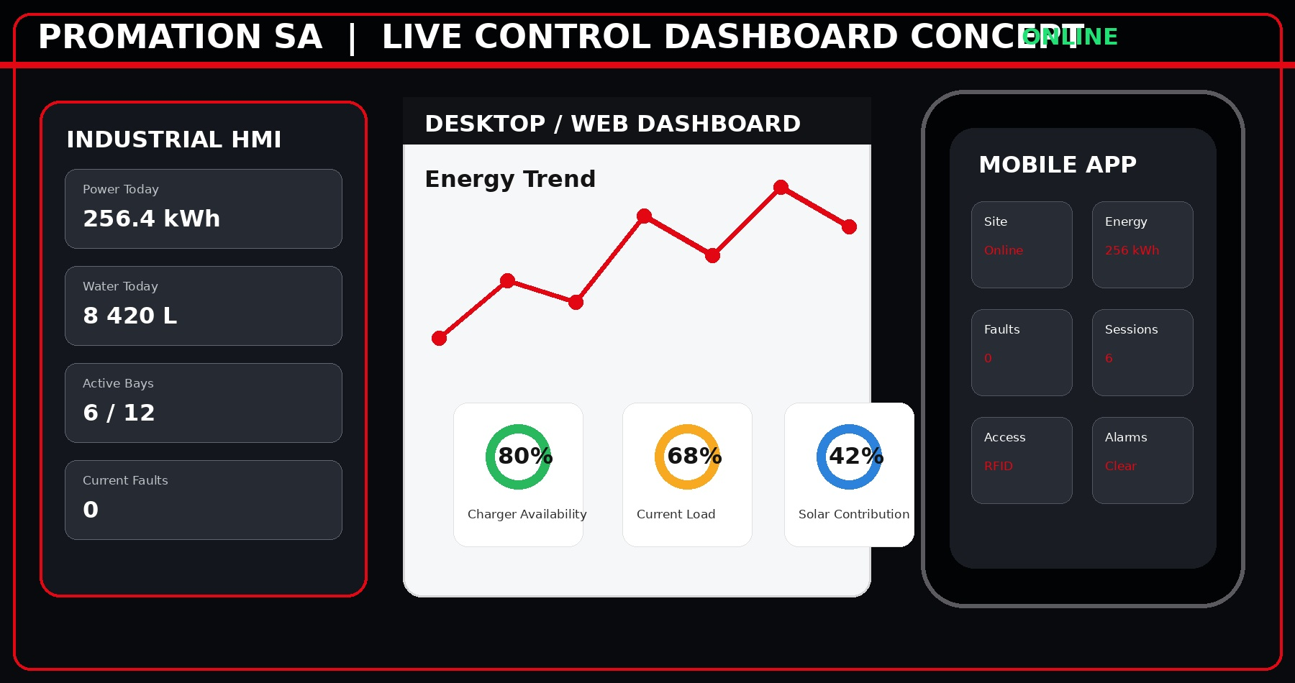
PLC PROGRAMMING  Reliable logic for equipment, machines, production processes and plant systems. | SCADA SYSTEMS  Desktop and operator dashboards for monitoring, alarms and daily visibility. |  | CONTROL PANELS  New panels, upgrades, protection, neat wiring and field integration.
FAULT FINDING  Structured diagnostics to reduce downtime and prevent recurring faults. | REMOTE MONITORING  Plant status, alarms and reports available to owners and managers. |  | OPTIMIZATION  Reduce waste, improve reliability and increase performance using measured data.
IDEAL FOR  ✓ Manufacturing plants and industrial factories.  ✓ Farms, pump stations and irrigation systems.  ✓ Mines, processing facilities and commercial plants.  ✓ Any site where downtime and poor visibility cost money. |  | CLIENT OUTCOMES  ✓ Reduced unplanned downtime.  ✓ Improved reliability and maintenance planning.  ✓ Lower operational waste through better measurement.  ✓ Better control over staff, equipment and process flow.

SMART HOMES & PREMIUM ACCOMMODATION | PAGE 4
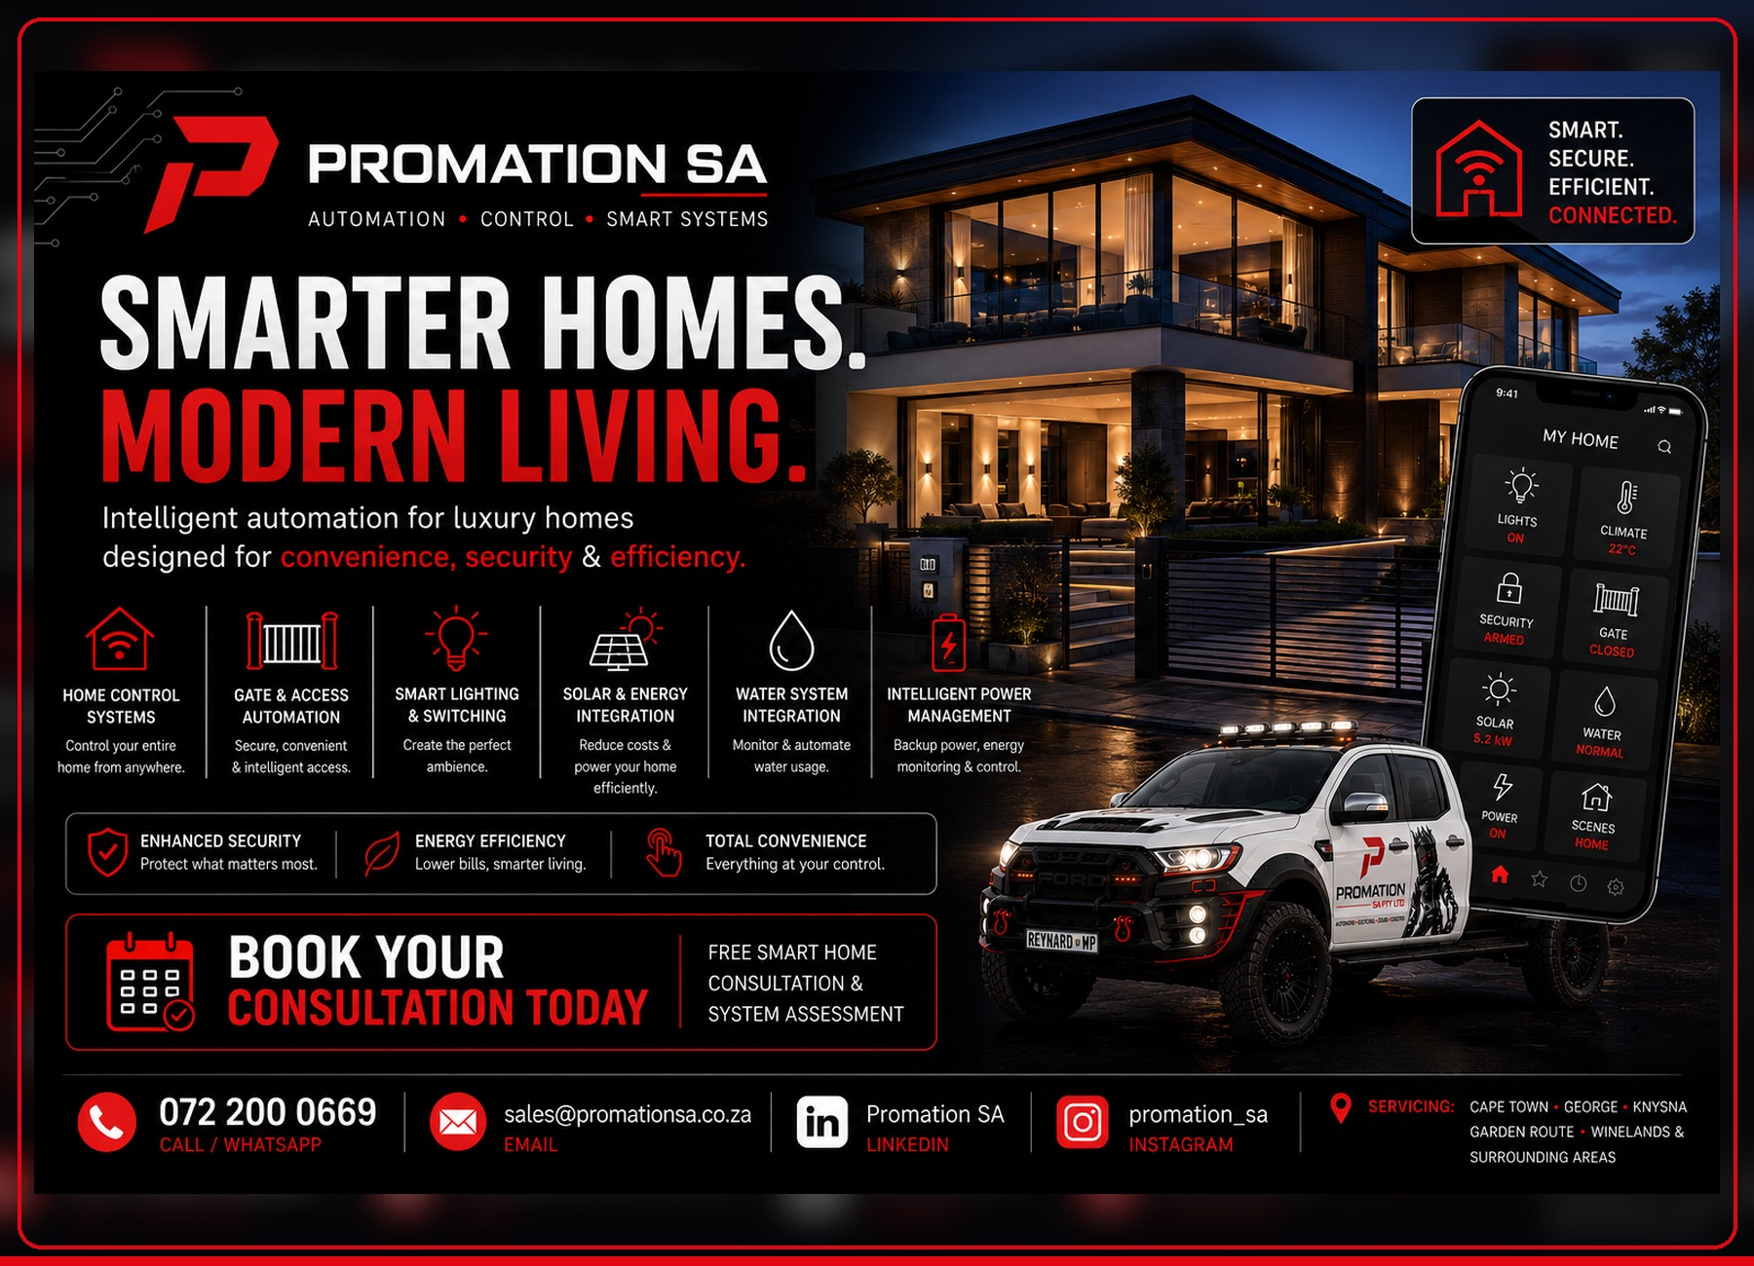 | 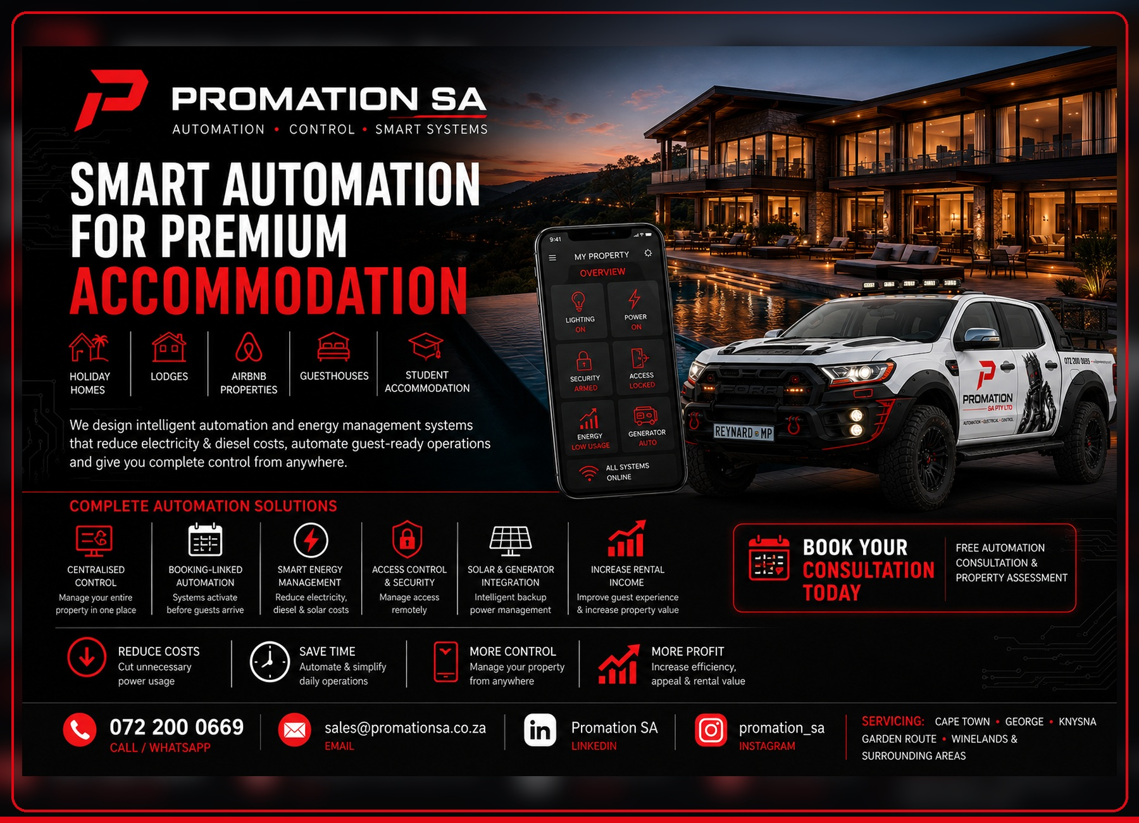
HOME CONTROL  Lighting, access, climate, security, power, water and energy management from one platform. | PREMIUM GUEST CONTROL  Booking-linked automation, guest-ready scenes and remote owner visibility. |  | ENERGY MANAGEMENT  Solar, generator, battery and load monitoring readiness for lower running costs.
ACCESS & SECURITY  Gate automation, access control, alarms and property security integration. | MODERN FEEL  High-end interfaces and control screens that match premium homes and accommodation. |  | OWNER FREEDOM  Manage and monitor key property systems without being on site all day.
FOR HOMEOWNERS, DEVELOPERS, LODGES, GUESTHOUSES, AIRBNB PROPERTIES AND HOLIDAY HOMES.
POPULAR SOLUTION AREAS  ✓ Smart lighting and switching.  ✓ Gate and access automation.  ✓ Solar, generator and intelligent power management.  ✓ Water system monitoring and automation. |  | BUSINESS BENEFITS  ✓ Reduce electricity and diesel costs.  ✓ Automate guest-ready operations.  ✓ Increase rental appeal and property value.  ✓ Improve security, convenience and efficiency.

SMART EV CHARGING & ENERGY MONITORING | PAGE 5
More than a charger installation.  ✓ Safe EV charger installation planned from the DB board outward.  ✓ Optional dashboards for HMI, desktop and phone visibility.  ✓ RFID access, session tracking and guest / tenant usage readiness.  ✓ Solar contribution monitoring, load control readiness and future smart-energy expansion.  ✓ Ideal for hotels, lodges, guesthouses, wine farms, estates, dealerships, commercial properties and premium homes. | 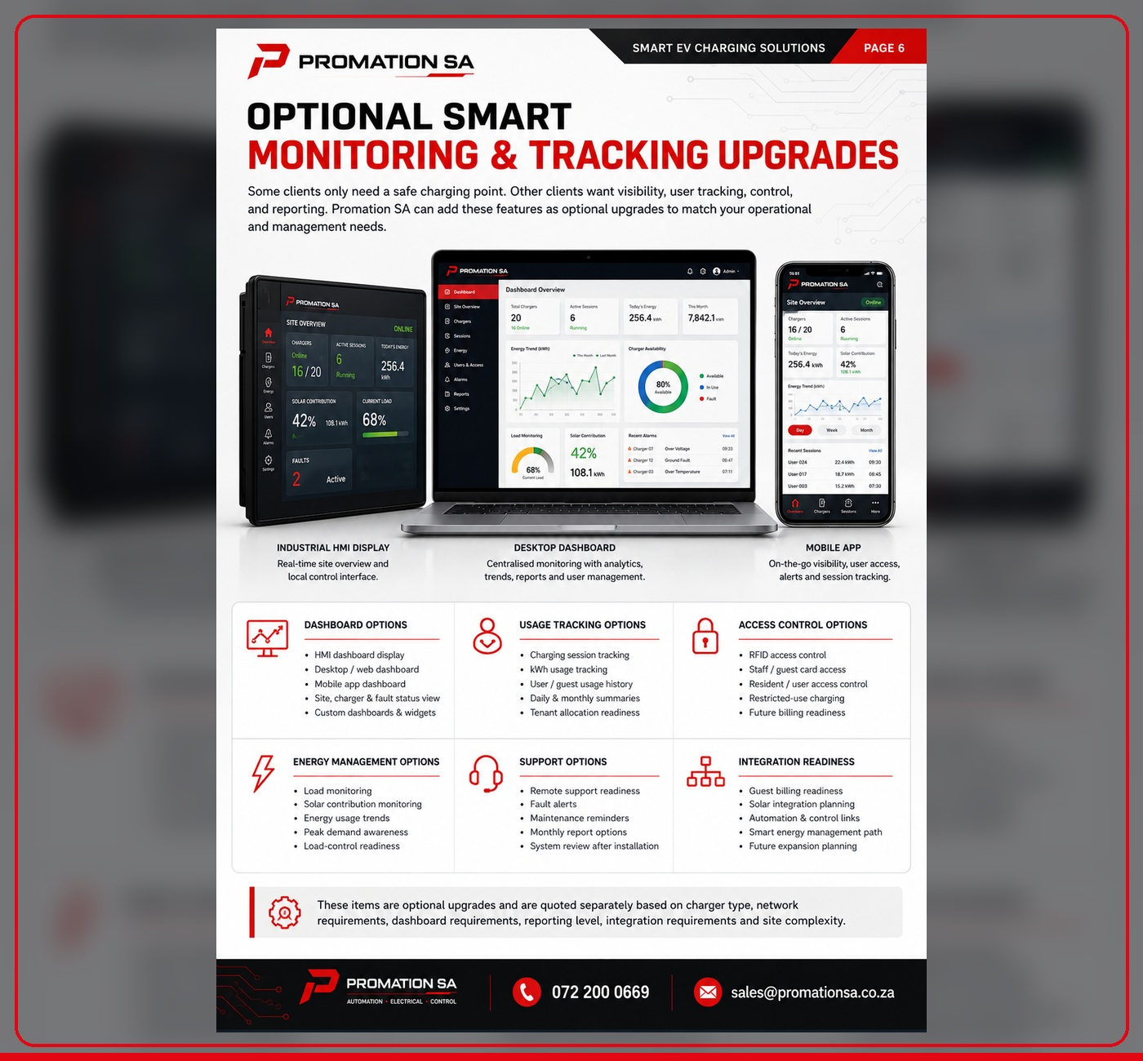
OPTIONAL UPGRADES  ✓ HMI dashboard display, desktop dashboard and phone dashboard.  ✓ Charging session tracking, kWh history and user reports.  ✓ RFID, staff / guest access and restricted-use charging. |  | ENERGY PATH  ✓ Load monitoring and peak demand awareness.  ✓ Solar integration planning and smart energy management.  ✓ Fault alerts, maintenance reminders and monthly reports.
START WITH SAFE EV CHARGING. EXPAND INTO SMART ENERGY WHEN THE BUSINESS CASE IS CLEAR.

CARWASH & OPERATIONS COST-CONTROL | PAGE 6
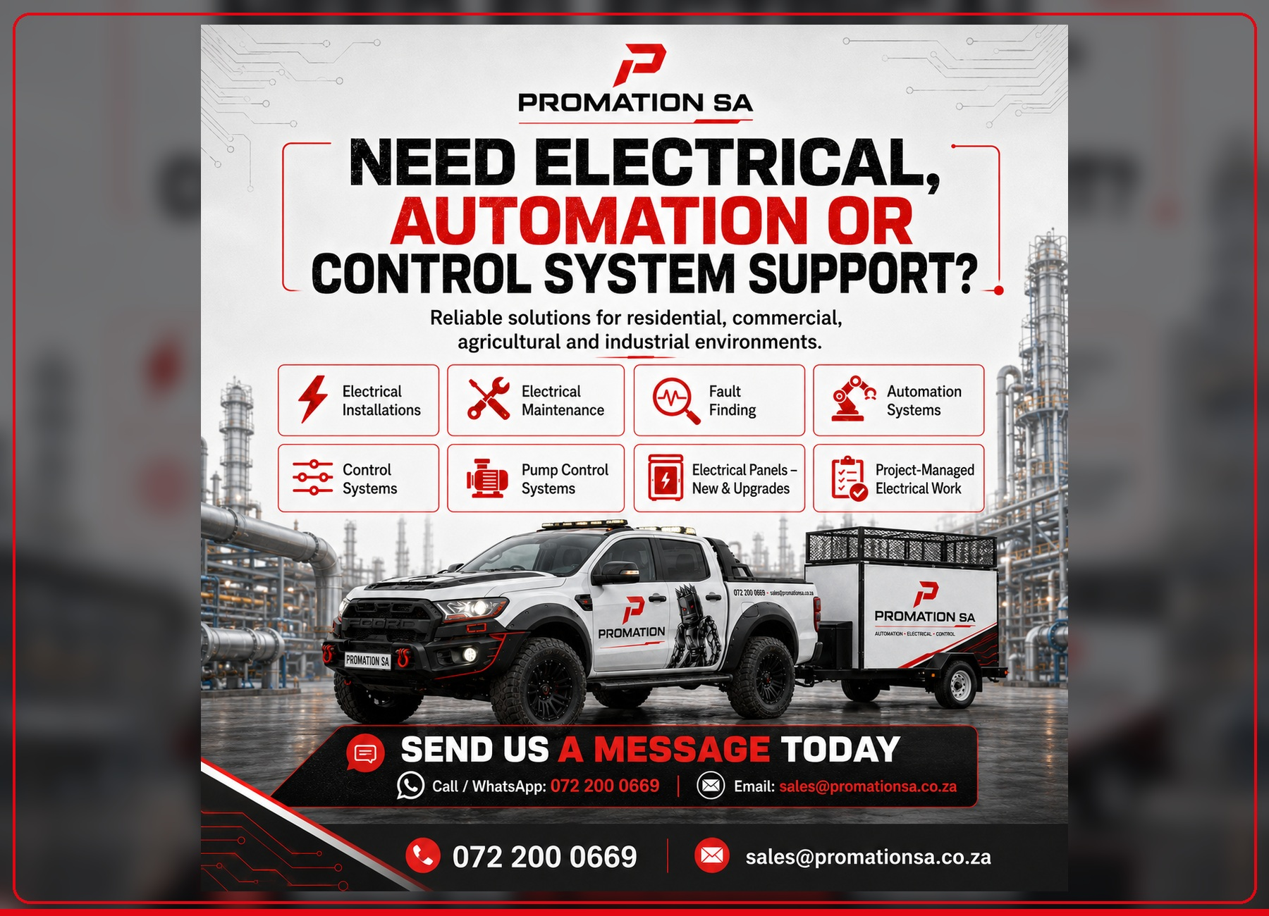
BUSINESS-CONTROL SYSTEM  ✓ Not a robot carwash and not a staff replacement.  ✓ Shows where electricity, water, equipment runtime and daily waste are created.  ✓ Gives the owner remote visibility while the manual service model stays in place.  ✓ Supports basic dashboard reporting, alarms and future expansion. |  | TYPICAL EXPANSION  ✓ Vacuum bay timers for interior / drying bays.  ✓ Soap / chemical dosing and low-level alarms.  ✓ Compressor, pressure washer and after-hours monitoring.  ✓ Package selection, hot wash readiness, POS readiness and maintenance reporting.
MEASURE  Power, water, vehicles and equipment behaviour are measured daily. | DISPLAY  HMI and dashboards show the information in plain language. | CONTROL  Timers, alarms, shutdown logic and settings reduce unnecessary running. | IMPROVE  After real data is available, the next upgrades are chosen with confidence.
OWNER VISIBILITY FROM ANYWHERE: SITE STATUS, VEHICLE COUNTS, ALARMS, ENERGY, WATER AND EQUIPMENT BEHAVIOUR.

PROJECT PROCESS, SUPPORT & CONTACT | PAGE 7
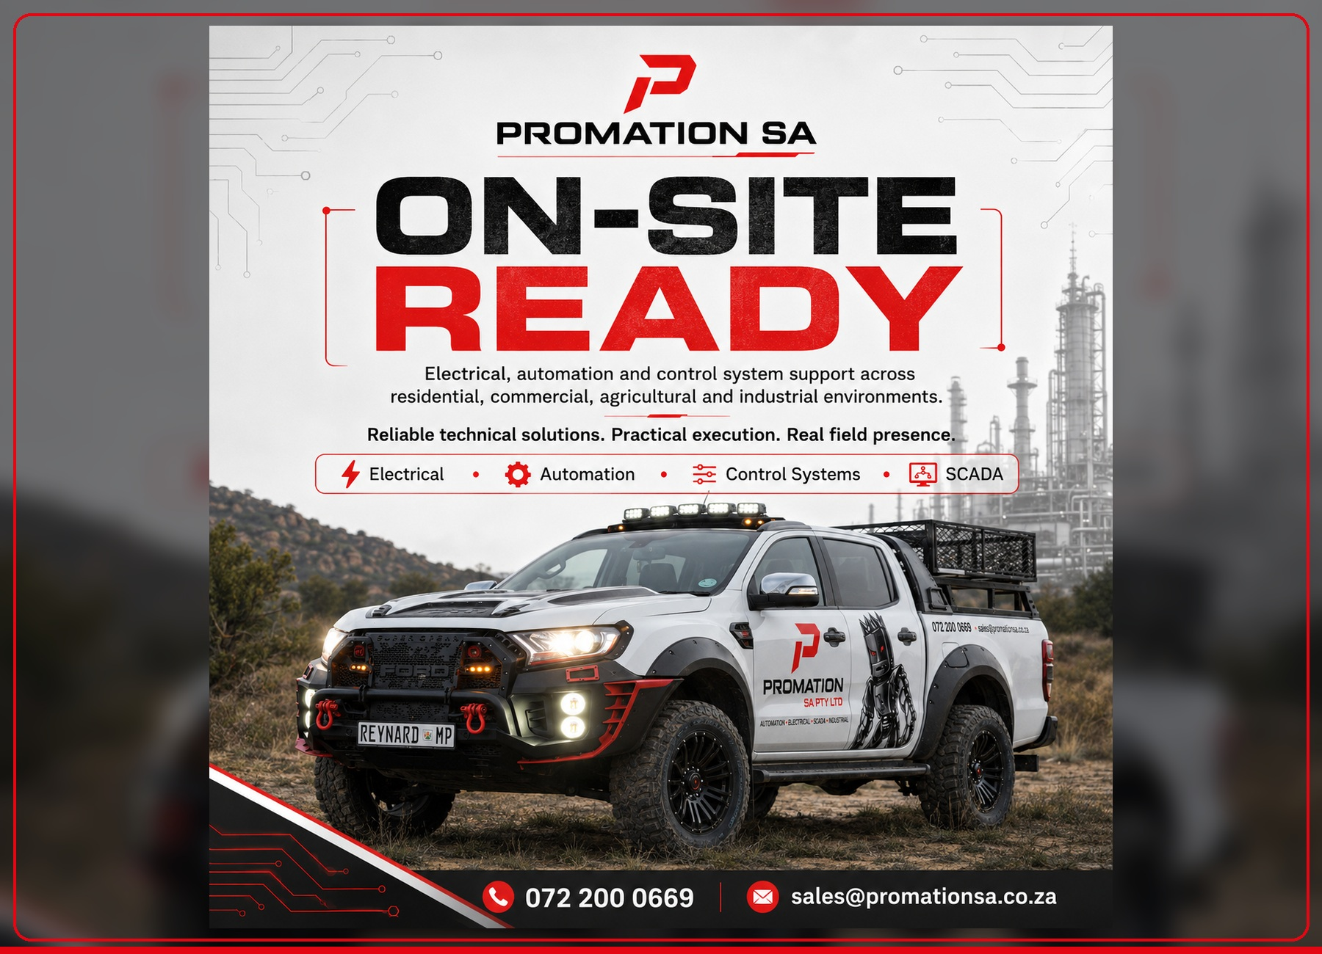 | 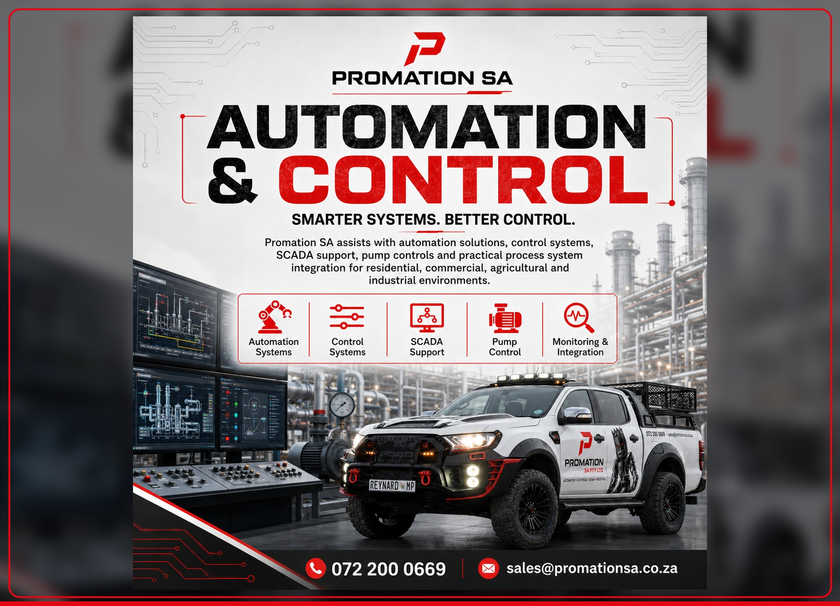
1. FREE TEAMS DISCUSSION  Understand the problem, ideal outcome and rough project direction before anyone over-spends. | 2. SITE ASSESSMENT  Inspect DB boards, machines, cable routes, network access, safety and real site conditions. | 3. DESIGN & QUOTATION  Prepare a practical scope, phased options and transparent pricing based on approved requirements.
4. INSTALLATION  Build panels, install wiring, sensors, PLC/HMI/SCADA, dashboards and protection devices. | 5. COMMISSIONING  Test alarms, validate operation and confirm that the client understands the system. | 6. SUPPORT & IMPROVE  Review early data, support maintenance and plan future upgrades only when justified.
PROMATION SA PTY LTD  Registration: 2026/281228/07  Call / WhatsApp: 072 200 0669  Email: sales@promationsa.co.za  LinkedIn: Promation SA  Instagram: promation_sa | SERVICE AREAS  • Cape Town  • George  • Knysna  • Garden Route  • Winelands  • Surrounding areas by arrangement
BOOK YOUR CONSULTATION TODAY | 072 200 0669 | sales@promationsa.co.za

