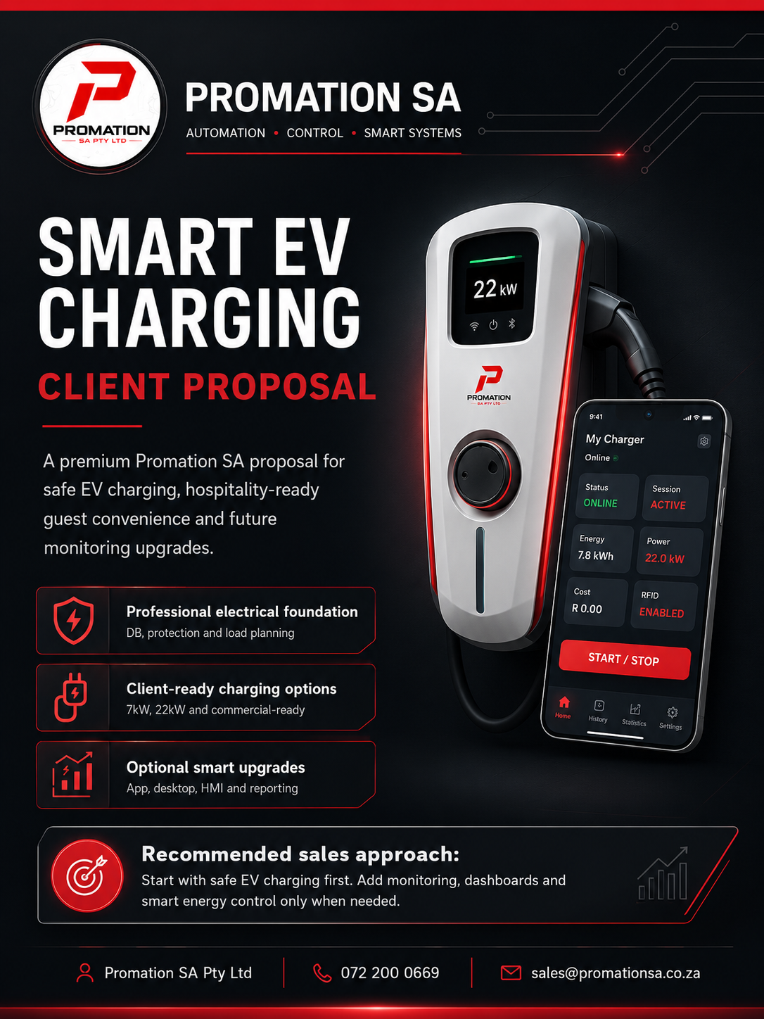

 | PROMATION SA | SMART EV CHARGING SOLUTIONS | PAGE 2

More Than a Charger Installation

Plain-English Promise

This solution is not only about installing a wall charger. It is about helping your property offer a modern guest amenity, prepare for EV-driving clients and create a practical foundation for future energy monitoring, solar integration and smart load control.

Promation SA installs EV charging with the bigger electrical and energy picture in mind, while keeping the offer easy for the client to understand.

Start simple. Expand smart.
A client can start with a safe, professional EV charging point and later add monitoring, tracking, dashboards, access control, guest reporting or solar/load-management integration when the business case is clear.
Premium guest amenity  Give guests and visitors a useful modern service. | Future-ready image  Position the property as prepared, modern and premium. | Electrical foundation  Plan the installation properly from the DB board outward.
Solar-ready path  Prepare for smarter charging and future solar integration. | Optional visibility  Add app, desktop or HMI views when needed. | One trusted partner  Start with EV charging and expand into broader smart energy support later.

Commercial note: Promation SA does not recommend over-investing before the site has been assessed. The professional approach is to confirm the electrical foundation first, then select the correct charger and optional smart upgrades.

 | PROMATION SA | SMART EV CHARGING SOLUTIONS | PAGE 3

Why EV Charging Makes Business Sense

The business case is not only the charger. The business case is how the charger improves the property offer.
What the property gains  - A premium guest amenity that can be advertised.  - A more modern and future-ready property image.  - A practical differentiator against competitors.  - A starting point for smart energy monitoring.  - A safer approach than poor ad-hoc charging. | Why the timing matters  - Early movers can advertise charging before competitors.  - Hotels and lodges can attract EV-driving travellers.  - Estates can prepare before residents demand capacity.  - Dealerships can support EV sales and customer charging.  - Clients can start with a correct foundation instead of overbuying.
The cost of waiting
If competitors start advertising EV charging before your property does, you may lose early-mover advantage. Installing early helps position the property as modern, prepared and premium without needing to buy the biggest system on day one.
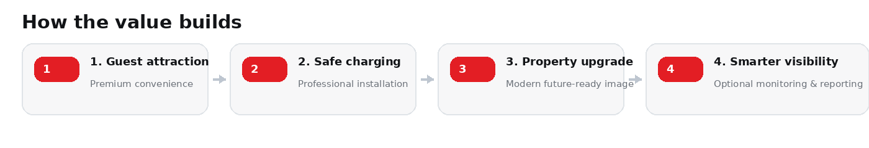

No exaggerated promise is needed. The honest sale is simple: EV charging can improve convenience, strengthen property positioning and create a platform for future smart energy upgrades.

 | PROMATION SA | SMART EV CHARGING SOLUTIONS | PAGE 4

Who This Solution Is Designed For

Client Type | Why It Makes Sense | Recommended Start
Hotels | EV charging can become a premium guest amenity and marketing differentiator. | Option 2
Lodges | Ideal for overnight guests who can charge while staying. | Option 2
Guesthouses | Affordable way to offer modern convenience to higher-value guests. | Option 1 or 2
Wine farms | Supports tourism, premium visitors and longer guest dwell time. | Option 2
Estates | Prepares the estate for residents and visitors with EVs. | Option 2 or 3
Car dealerships | Supports EV sales, customer charging and brand image. | Option 3
Commercial properties | Adds value for staff, tenants and visitors. | Option 2 or 3
Premium homes | Convenient private charging with future solar readiness. | Option 1
Hospitality angle
For hotels, lodges, guesthouses and wine farms, EV charging is not only practical. It can also support premium positioning, guest convenience and stronger marketing.

Promation SA will confirm the correct starting option during site assessment after reviewing supply capacity, parking layout, cable route and operating goals.

 | PROMATION SA | SMART EV CHARGING SOLUTIONS | PAGE 5

Recommended Starting Options

The correct option depends on property type, usage expectations, available supply and whether the client needs access control and reporting from day one.

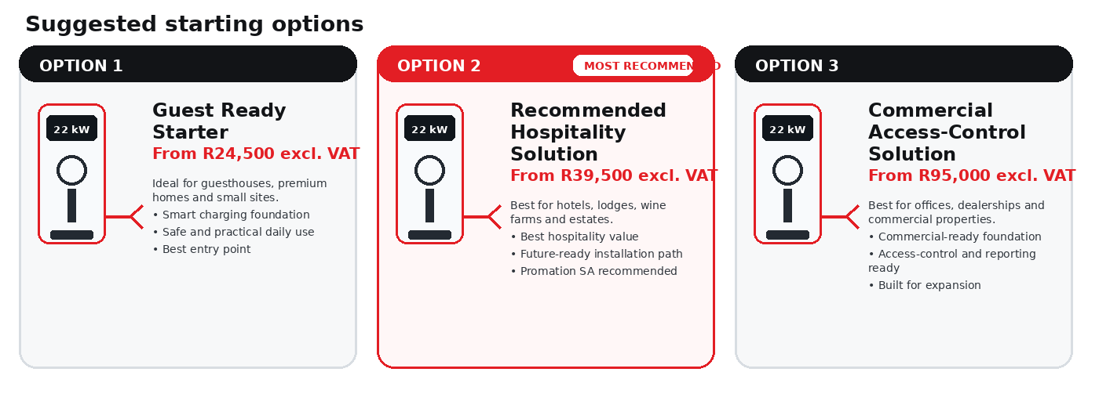
Option | Typical client | Starting from | What matters most
Option 1 | Guesthouse / premium home | R24,500 excl. VAT | Affordable smart charging foundation
Option 2 | Hotel / lodge / wine farm / estate | R39,500 excl. VAT | Best hospitality fit and strongest overall value
Option 3 | Commercial property / dealership | R95,000 excl. VAT | Best where user access, control and future reporting matter most
Pricing note
These starting prices are guidance figures for client discussion. Final pricing is subject to site conditions, cable route, DB capacity, charger model, protection requirements, civil work if needed and the final client-approved scope.

 | PROMATION SA | SMART EV CHARGING SOLUTIONS | PAGE 6

Optional App, Desktop & HMI Monitoring

Monitoring should look professional because it helps clients understand the upgrade path. The examples below have been updated to better reflect a cleaner and more realistic premium Promation SA presentation style.

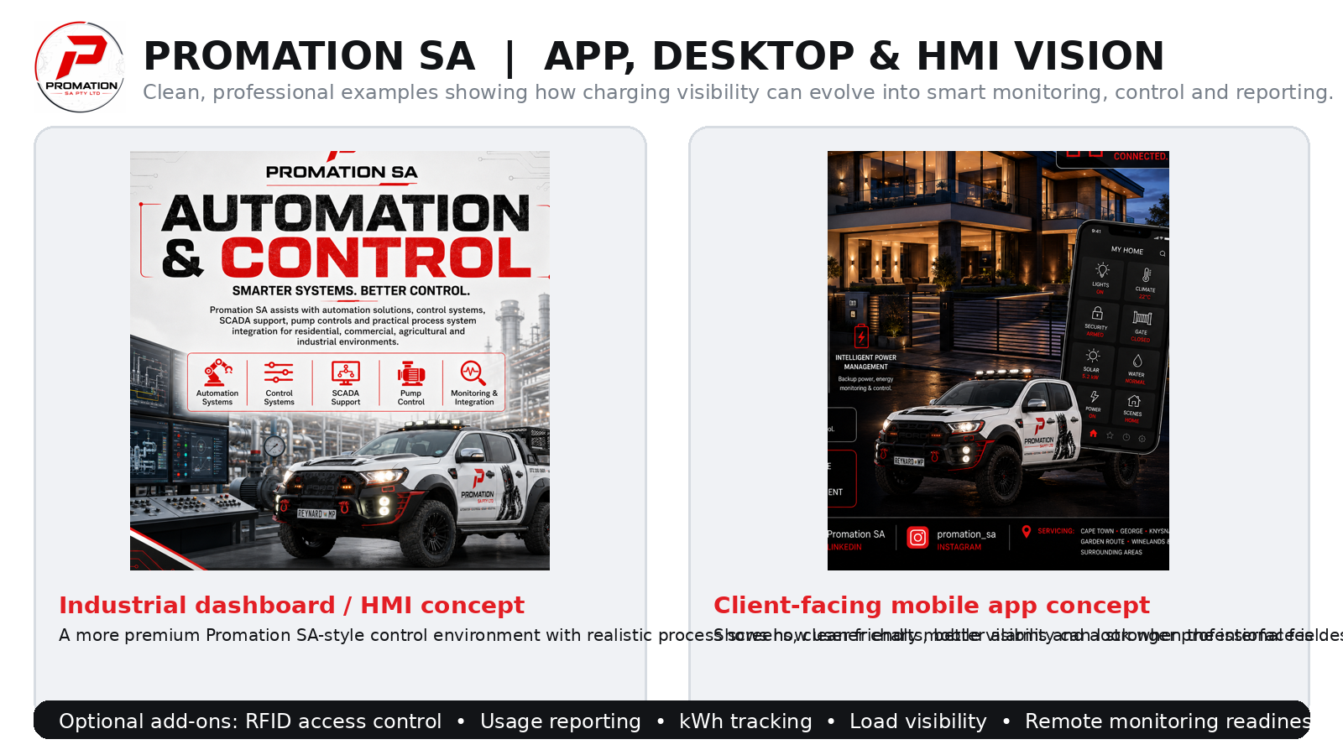

Important positioning
Monitoring, dashboards, reporting and smart control are optional extras. They are not required to start with EV charging, but they create a very strong future upsell path for the right client.

Examples of optional smart upgrades include: HMI display, desktop dashboard, mobile app visibility, RFID access control, user reporting, kWh tracking, alarm and fault alerts, solar/load visibility and remote monitoring readiness.
These features are quoted separately based on charger type, network requirements, dashboard requirements, reporting level, integration needs and site complexity.

 | PROMATION SA | SMART EV CHARGING SOLUTIONS | PAGE 7

Why Promation SA Is Different

Promation SA is the better choice for clients who want more than a basic charger on the wall.

Basic Installer | Promation SA
Installs the charger only. | Looks at the full electrical and smart energy picture.
May not plan for future load growth. | Considers DB capacity, future EV growth and expansion planning.
Limited automation and monitoring knowledge. | Can add monitoring, reporting, HMI, desktop or mobile dashboard options.
The charger is the end of the job. | The charger can become the first step toward energy monitoring, solar integration and load management.
Limited future support. | Can support electrical upgrades, automation, smart control, remote monitoring and reporting.
Competes mainly on price. | Competes on long-term value, reliability and system thinking.
The Promation SA advantage
The EV charger is only the starting point. The longer-term value is the ability to expand into smart energy monitoring, load management, reporting and automation when the client is ready.

This difference matters most for hospitality, estate and commercial clients who do not want to redo work later because the first installation was too basic or poorly planned.

 | PROMATION SA | SMART EV CHARGING SOLUTIONS | PAGE 8

Supportive Services Available

During an EV charger installation, additional site work may be required or recommended. Promation SA can assist with the wider electrical and smart energy requirements.
Electrical Support  - DB board inspections  - DB upgrades  - Dedicated EV charger circuits  - Surge protection  - Earth leakage and safety protection  - Cable route planning  - Trenching and civil coordination where required  - Electrical compliance support | Smart Energy Support  - Load balancing  - Energy monitoring  - Load monitoring  - Solar integration planning  - Battery backup integration readiness  - Peak demand awareness  - Smart load-control planning
Automation and Monitoring Support  - HMI dashboard options  - Desktop dashboard options  - Mobile dashboard options  - Alarm and fault monitoring  - Usage reports  - Maintenance reminders  - Remote monitoring readiness | Commercial Support  - RFID/user access planning  - Guest billing readiness  - Tenant/resident usage allocation readiness  - Staff charging control  - Monthly reporting options  - Maintenance plan options
Expansion wording
These services are quoted separately where required and allow the client to expand from a basic charger installation into a complete smart energy solution over time.

Examples of follow-on work can include DB upgrades, extra charging points, reporting dashboards, RFID access, solar readiness or broader smart energy management support.

 | PROMATION SA | SMART EV CHARGING SOLUTIONS | PAGE 9

How the Process Works

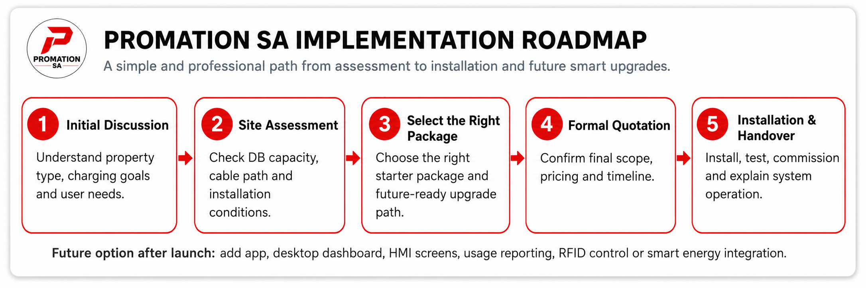
1. Initial Discussion  Confirm property type, charging need, available supply and preferred outcome. | 2. Site Assessment  Inspect DB board, cable routes, parking area, charger location and capacity. | 3. Package Selection  Select Option 1, Option 2 or Option 3 as the starting point.
4. Optional Upgrade Selection  Decide whether monitoring, tracking, dashboards, access control or reporting is needed. | 5. Formal Quotation  Prepare final quotation based on actual site conditions and selected scope. | 6. Installation  Install the approved charger system professionally with required protection.
7. Testing and Commissioning  Test, commission and check safe operation. | 8. Client Handover  Provide basic handover so the client understands how to use the charger. | 9. Optional Monitoring Upgrade  Configure dashboards, reporting, tracking or access control if selected.
Professional approach
Start with safe EV charging. Expand into smart energy monitoring when the business case is clear.

 | PROMATION SA | SMART EV CHARGING SOLUTIONS | PAGE 10

Recommended Next Step

The correct next step is not to guess the final price from a distance. The correct next step is to confirm site readiness and select the right starting option.
Recommended action
Book an EV Charging Site Assessment. Promation SA will confirm DB condition, available supply, charger location, cable route, protection requirements, correct charger size and optional monitoring or tracking requirements.

Please select your preferred starting point:
[ ]  Option 1: Guest Ready Starter  From R24,500 excl. VAT | [ ]  Option 2: Recommended Hospitality Solution  From R39,500 excl. VAT | [ ]  Option 3: Commercial Access-Control Solution  From R95,000 excl. VAT
Optional upgrades required:
- HMI dashboard | - Desktop dashboard | - Phone/mobile dashboard
- App-based viewing where supported | - Usage tracking | - kWh tracking
- RFID access control | - Guest/user reporting | - Solar integration planning
- Load monitoring | - Remote monitoring readiness | - Guest billing readiness
Final pricing note
Final pricing is subject to confirmed site conditions, cable routes, DB condition, electrical capacity, charger model, protection requirements, network requirements, optional upgrades and client-approved scope.
To move forward, select the preferred starting option and Promation SA will confirm site readiness, final scope and installation requirements.

