
SUBCONTRACTOR & TECHNICAL PARTNER PROFILE
For main contractors, electrical companies, system integrators, facility service providers and project teams
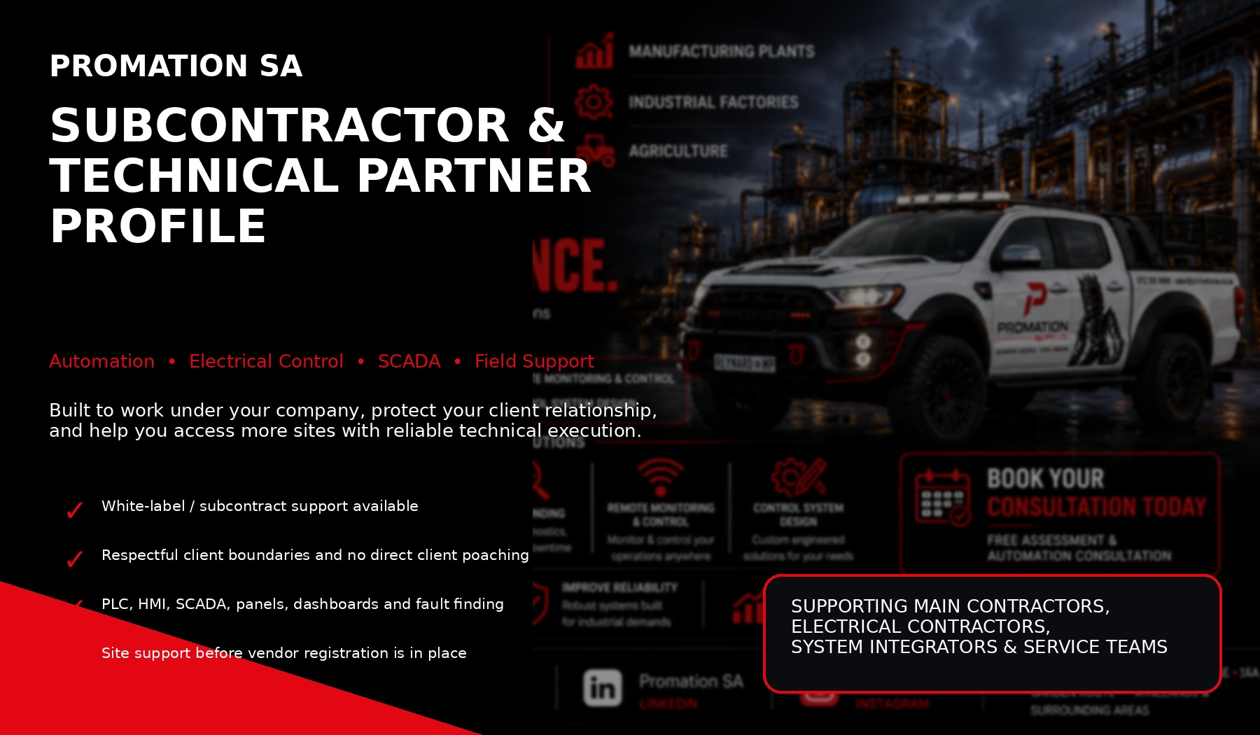
WE HELP YOUR COMPANY SAY YES TO MORE TECHNICAL WORK WHILE YOU KEEP THE CLIENT RELATIONSHIP.
SUBCONTRACT UNDER YOU  We support your delivery team while your company remains the primary contractor or vendor. | SITE ACCESS SUPPORT  Useful where your company already has vendor access and Promation SA is still building vendor approvals. | CLIENT RELATIONSHIP PROTECTED  We work within agreed boundaries and do not bypass your commercial route.

WHY PARTNER WITH PROMATION SA | SUBCONTRACTOR PARTNER PROFILE
This profile is designed for companies that already have client relationships, site access or vendor registration, but need reliable technical support to complete automation, electrical control, SCADA, monitoring or fault-finding work. Promation SA can operate as a subcontractor, white-label support team or specialist technical partner depending on the project arrangement.
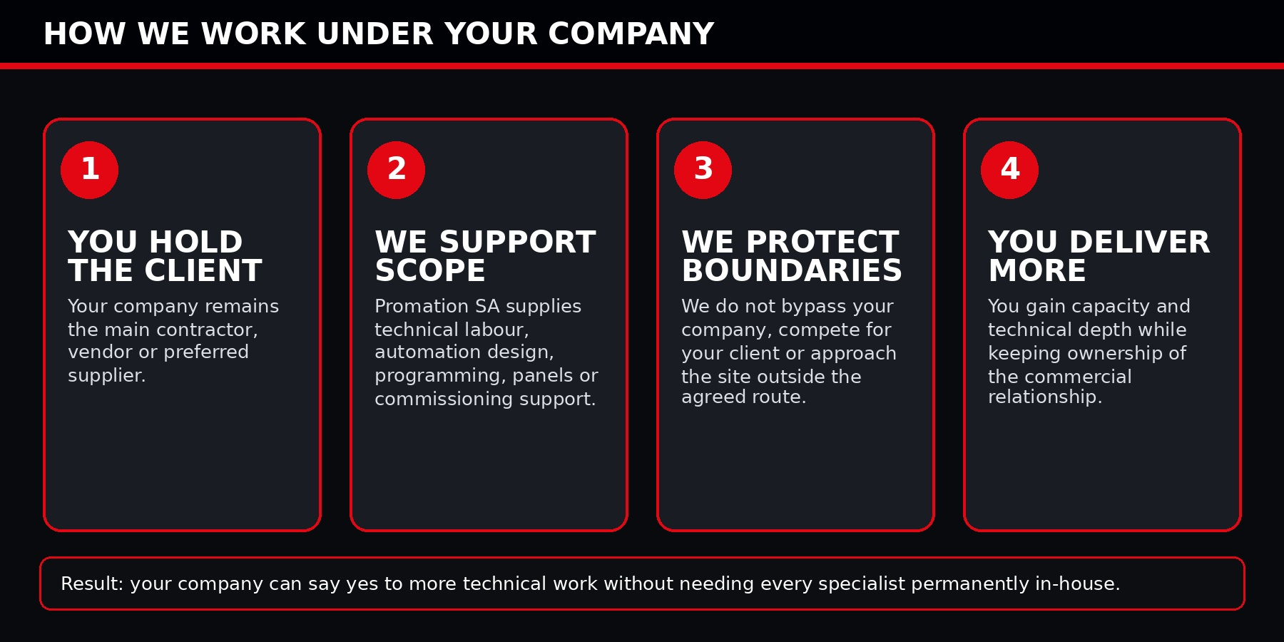
MORE CAPABILITY WITHOUT PERMANENT OVERHEAD  Bring in technical support when needed instead of carrying every specialist full-time. | FASTER RESPONSE ON TECHNICAL WORK  Use us for PLC, HMI, SCADA, panels, commissioning, fault finding and field technical execution. | PROTECT YOUR CLIENT BASE  Your company stays in control of commercial communication, pricing, quotations and client ownership.
BETTER SITE CREDIBILITY  Offer stronger automation and monitoring capability when tendering or quoting work. | PRACTICAL FIELD MINDSET  We focus on what works on site, not only paperwork and theory. | EXPANDABLE SUPPORT  Start with one site or one task, then scale into ongoing support or maintenance.
SUBCONTRACTING IS THE BRIDGE: YOUR ACCESS + OUR TECHNICAL EXECUTION = MORE DELIVERABLE PROJECTS.

CORE TECHNICAL CAPABILITIES | SUBCONTRACTOR PARTNER PROFILE
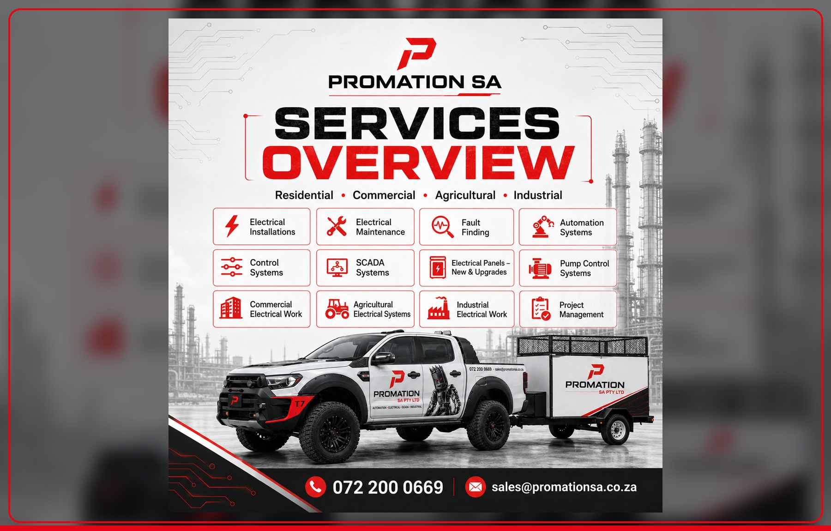
PLC PROGRAMMING  Delta and general industrial PLC support, logic updates, sequence control, troubleshooting and site commissioning. | HMI AND SCADA  Operator screens, dashboards, status views, alarms, trends, reports and practical user interfaces. | CONTROL PANELS  New panel builds, upgrades, rewiring support, documentation, testing and commissioning assistance.
FAULT FINDING  Breakdown support, sensor issues, motor/control problems, process faults and control loop diagnosis. | REMOTE MONITORING  Phone, desktop and HMI dashboard concepts for visibility, alarms and reporting. | ELECTRICAL SUPPORT  DB inspections, electrical upgrades, dedicated circuits, cable route planning and site electrical coordination.
SMART ENERGY  Energy monitoring, load monitoring, solar integration planning and smart load-control readiness. | AUTOMATION DESIGN  Control system architecture, IO planning, equipment interfaces, drawings and staged upgrade planning. | PROJECT SUPPORT  Scope clarification, site walkdowns, installation planning, commissioning checklists and handover support.

WHERE WE CAN SUPPORT YOUR PROJECTS | SUBCONTRACTOR PARTNER PROFILE
Promation SA can support companies serving industrial, agricultural, commercial, hospitality, accommodation, EV charging, smart home and premium property environments. The common thread is simple: clients need better control, better visibility and better reliability.
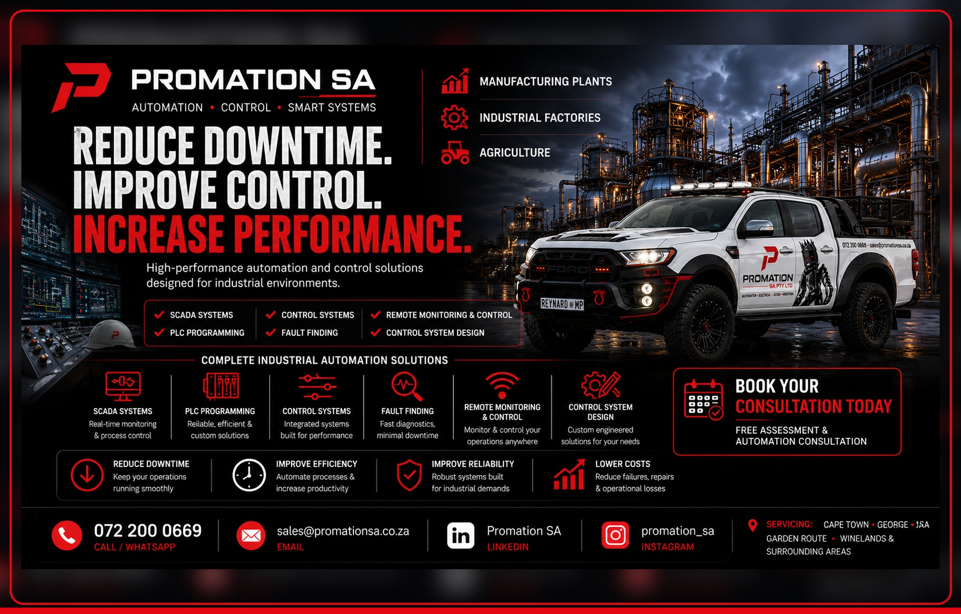
Sector | Subcontract Support We Can Provide | Value to Your Company
Manufacturing & factories | PLC/HMI support, panels, fault finding, SCADA and monitoring. | Adds automation capability to your technical offering.
Agriculture & farms | Pump control, irrigation interfaces, sensors, power monitoring and remote alarms. | Helps you serve remote sites with practical control solutions.
Mines & processing | Control panels, fault-finding support, site inspections and reporting dashboards. | Specialist assistance for demanding technical environments.
Hospitality & estates | EV charging, access control, smart energy, reporting and dashboards. | Adds modern energy and automation solutions to property clients.
Carwash & commercial operations | Cost-control dashboards, equipment monitoring, water/power tracking and bay status. | Creates business-control offers beyond normal electrical work.
Luxury homes & accommodation | Smart lighting, gate/access, solar/generator integration and mobile control concepts. | Supports premium client upgrades and high-value property work.

HOW WE PROTECT THE MAIN CONTRACTOR | SUBCONTRACTOR PARTNER PROFILE
COMMERCIAL BOUNDARIES  ✓ Your company stays the primary client-facing contractor unless otherwise agreed.  ✓ Promation SA does not approach your client directly for separate work on the same opportunity.  ✓ Pricing, margin and final quotations can remain under your company control.  ✓ White-label or behind-the-scenes support can be discussed per project. | PROFESSIONAL CONDUCT  ✓ We can work under your site rules, safety processes and reporting structure.  ✓ We can sign NDAs or subcontractor agreements where required.  ✓ We can support documentation, handover notes, photos and commissioning records.  ✓ We communicate clearly when scope changes, risks or site issues appear.
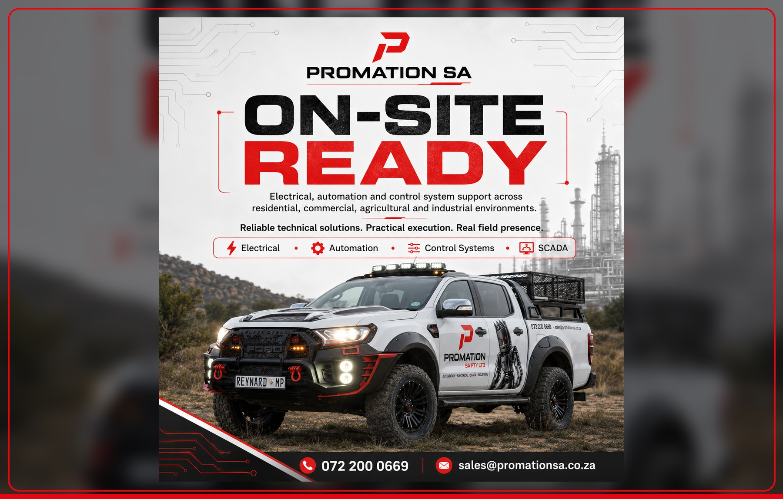
NO CLIENT POACHING  We understand that access to the site belongs to the company that brought the opportunity. | CLEAR ROLE DEFINITION  We confirm whether we are acting as installer, programmer, support technician, panel builder or commissioning partner. | VENDOR PATHWAY SUPPORT  While vendor registration is pending, we can support as your subcontractor where site rules allow.
SCOPE DISCIPLINE  We avoid informal scope creep and report additional work back to the main contractor. | QUALITY MINDSET  Our goal is to help your company look stronger, more capable and more reliable. | LONG-TERM PARTNERSHIP  The better we protect your relationships, the more repeat work both companies can win.

ENGAGEMENT MODELS & TYPICAL USE CASES |  | SUBCONTRACTOR PARTNER PROFILE
WHITE-LABEL TECHNICAL SUPPORT  We assist under your brand or project structure where required. | NAMED SUBCONTRACTOR  Promation SA is listed as your technical subcontractor for automation or control scope. | OVERFLOW CAPACITY  Bring us in when your team is overloaded, delayed or missing a specialist skill.
TENDER SUPPORT  We help define automation, SCADA, monitoring or dashboard scope before pricing. | EMERGENCY SUPPORT  Field support for breakdowns, faults, panel issues or system failures. | COMMISSIONING SUPPORT  Assistance during testing, setup, sign-off and handover.
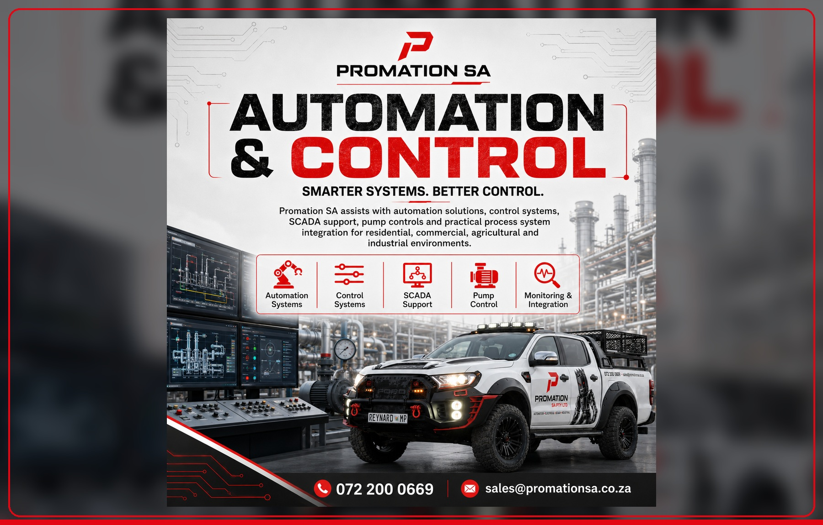
Project Stage | How Promation SA Can Help | Output
Before quote | Site walk-through, scope notes, rough system concept and risk identification. | Better-informed quotation and fewer surprises.
Design & planning | Control concept, IO list, panel approach, dashboard concept and phased plan. | Clearer scope for client approval.
Installation | Panel wiring support, field device coordination, cable checks and site changes. | Cleaner execution and reduced delays.
Programming | PLC, HMI, SCADA logic, alarm setup, trends and operator screens. | Functional control system ready for commissioning.
Commissioning | Testing, fault correction, signal checks, sequence validation and operator handover. | System that is safe, usable and practical.
After support | Remote review, report improvements, maintenance recommendations and upgrade planning. | Ongoing value and future work opportunities.

DASHBOARD, MONITORING & REPORTING SUPPORT | SUBCONTRACTOR PARTNER PROFILE
A strong subcontracting advantage is that Promation SA can help your company offer modern dashboards and monitoring without needing to build a full software or automation department internally.
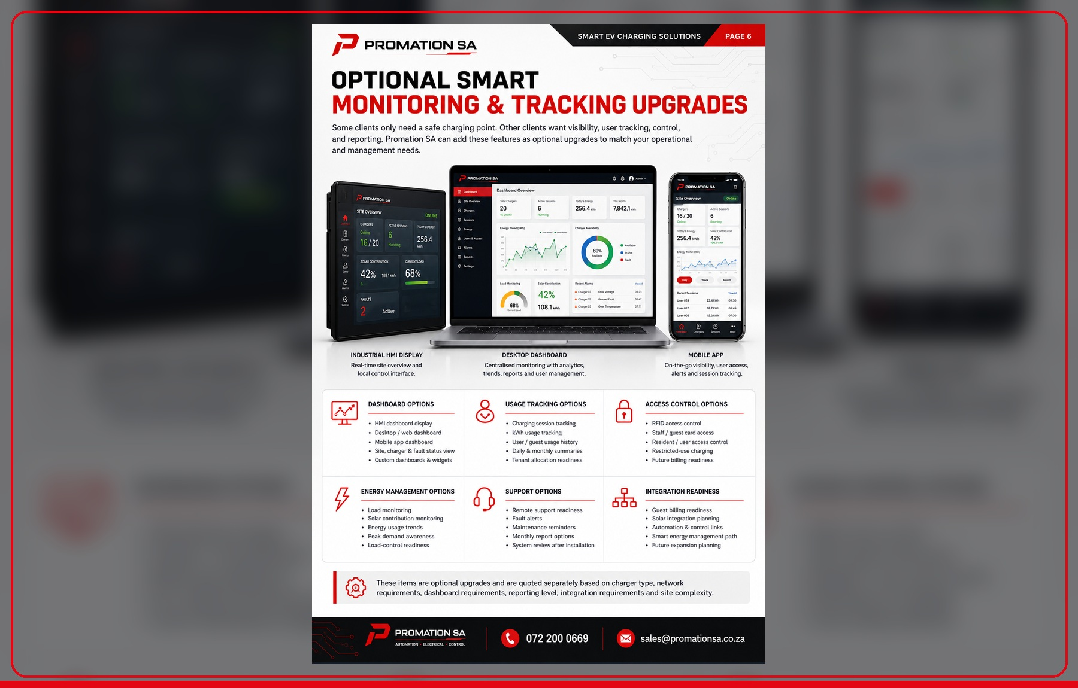
INDUSTRIAL HMI DISPLAYS  Local site overview, equipment status, alarms and operator prompts. | DESKTOP DASHBOARDS  Management reports, trends, energy use, faults, sessions and production insights. | MOBILE DASHBOARDS  On-the-go visibility for owners, supervisors and managers.
ENERGY TRACKING  kWh usage, peak demand awareness, load trends and solar contribution readiness. | ALARM SUPPORT  Fault alerts, maintenance reminders and abnormal condition visibility. | INTEGRATION READINESS  Future links to EV chargers, access control, solar, plant equipment, pumps or utilities.
MODERN VISIBILITY SELLS PROJECTS: CLIENTS UNDERSTAND DASHBOARDS FASTER THAN THEY UNDERSTAND PLC CODE.

SPECIALISED SOLUTION AREAS | SUBCONTRACTOR PARTNER PROFILE
These are examples of solution areas that can be delivered directly by Promation SA or under another company as a subcontracted technical package.
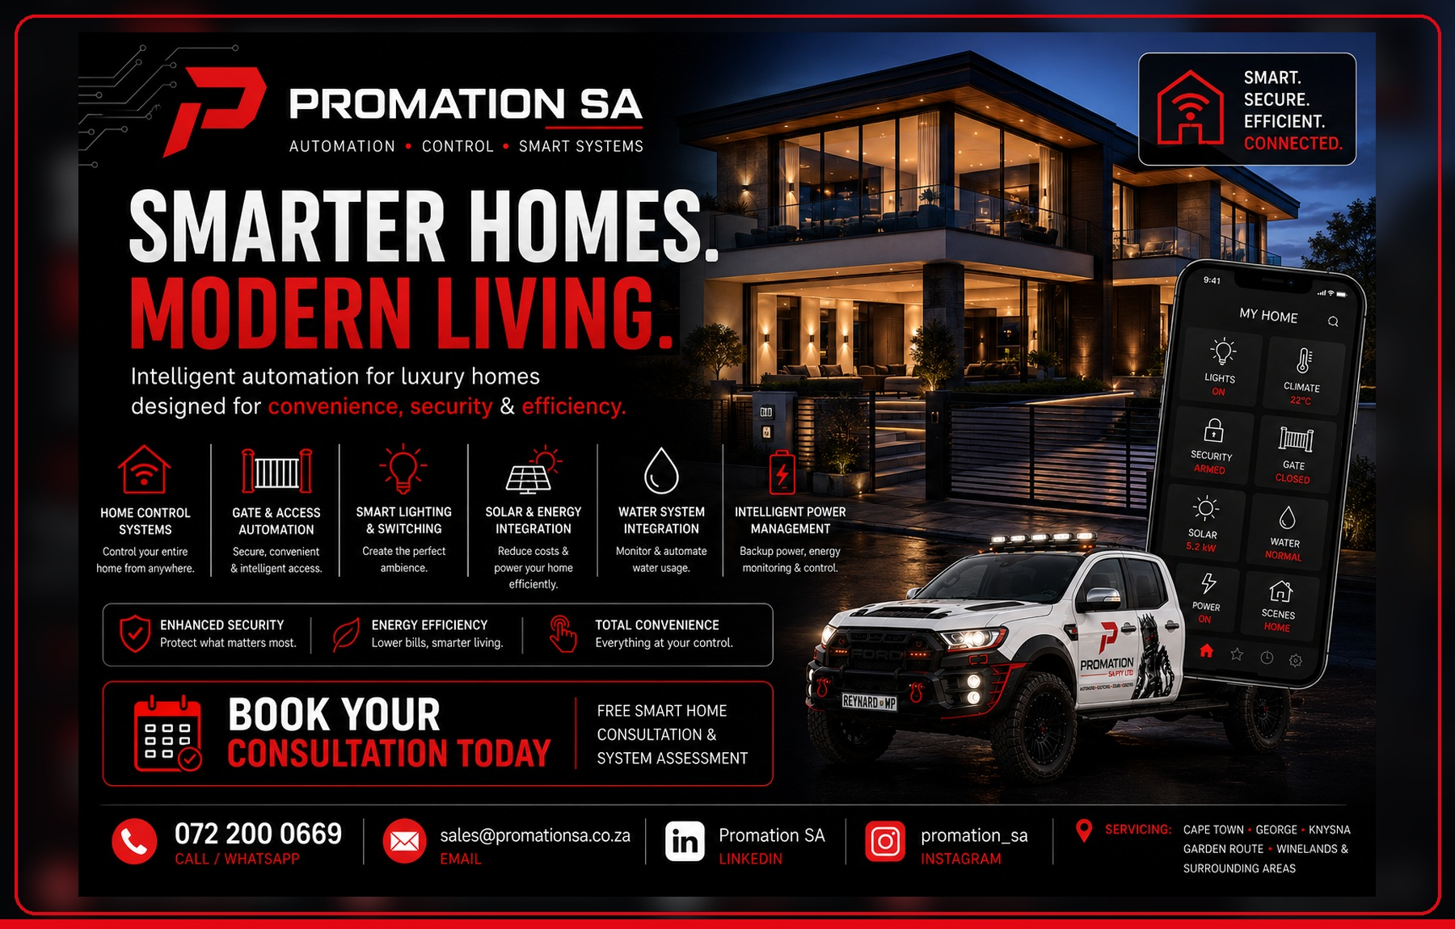 |  | 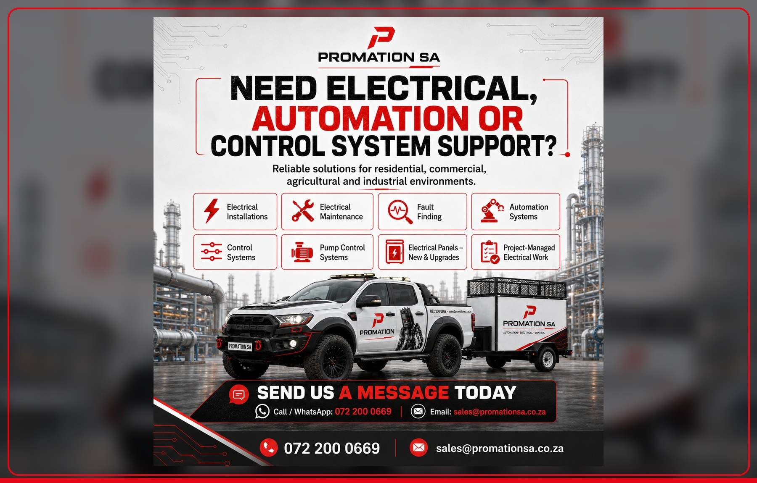
SMART HOMES & ACCOMMODATION  Gate/access, lighting, water, energy, solar/generator and mobile control support. | EV CHARGING & SMART ENERGY  EV readiness, dedicated circuits, monitoring, RFID/access readiness and load management path. |  | CARWASH COST CONTROL  Power, water, bay, equipment and remote dashboard solutions for commercial operations.
PUMP AND PROCESS CONTROL  Pump stations, water systems, tank levels, pressure, flow and protection logic. | INDUSTRIAL EFFICIENCY  PLC/SCADA upgrades, downtime reduction, dashboards and maintenance visibility. |  | PANEL UPGRADES  New panels, DB upgrades, control wiring, IO expansion and documentation support.

RECOMMENDED NEXT STEP | SUBCONTRACTOR PARTNER PROFILE
The best way to start is with a controlled trial project or a short subcontracting arrangement. This allows both companies to test communication, quality, boundaries and delivery speed before scaling into larger work.
SUGGESTED FIRST ENGAGEMENT  ✓ One site walk-through under your company.  ✓ One clearly defined PLC/HMI/SCADA/panel/fault-finding task.  ✓ A short agreed scope with boundaries, rates and reporting format.  ✓ End-of-job notes and recommendations for the next phase. | INFORMATION NEEDED FROM YOUR SIDE  ✓ Company name and main contact person.  ✓ Project type, site location and client/vendor access route.  ✓ Required confidentiality or white-label requirements.  ✓ Scope, deadline, site rules and safety requirements.
LET US HELP YOU GET ON SITE, SOLVE THE TECHNICAL PROBLEM AND MAKE YOUR COMPANY LOOK LIKE THE STRONGEST OPTION.
PROMATION SA PTY LTD
Registration No: 2026/281228/07
Call / WhatsApp: 072 200 0669
Email: sales@promationsa.co.za
LinkedIn: Promation SA
Instagram: promation_sa
Service Areas: George, Knysna, Garden Route, Cape Town, Winelands and surrounding areas
Subcontractor work is subject to agreed scope, site access rules, safety requirements, availability and written commercial arrangement.

